seventhtownresearch.ca

Content audit
Home
[membership application form]
[search land records]
[search Heal database]
[search names database]
- About
- Memories
- Research at the MAGRC
  - Victoria Cross Library
- Marilyn Adams U.E.
- Store
  - Publications list and order form
[order form]
- Contact
[presentation calendar]
[membership application form]
- Links
[html links]

Desirable functions & features
News postings
Event listings and registration
Books for sale and order form
Inventory management?
Paypal capability (TBD)
Database searches
Add reference code index?
Add extract of newly added info?
Membership form
Social sharing (Facebook, Twitter, etc.) & facebook page feed (improved)
Research request form
Responsive design, accessibility enabled, mobile-friendly
Newsletter [with email management]
Articles or features
Email management

Proposed content architecture

Site map
Home
- News
- Calendar of events
- Search panel
- Research requests [form]
- Social feed [Facebook]
Main menu
- About
- Products
  - Books
  - Land records
  - Event registration
  - Newsletter
- Tributes
  - Marilyn Adams
  - Memories
  - Sponsors
- Research resources
  - Land records
  - Names
  - Heal
  - Victoria Cross Library
  - Requests
- Contact us
  - Join
  - Contacts
Footer
- Membership form
- Hours
- Location

Content notes
Stories about research work
This day in County history (focus on people)
Links to other sites to be incorporate with appropriate content where relevant.
Social sites that require setting up:
Facebook site (not a group)
Twitter account?
Archive content over 5 years old.
Comments by form submission.

User behavior

Most visited pages Nov 2016 – Feb 2017
Page | Total
Based on top 10 pages each month.

Most downloaded documents Nov 2016 – Feb 2017
Document | Total
Based on top 10 downloads each month.

Design options

Themes
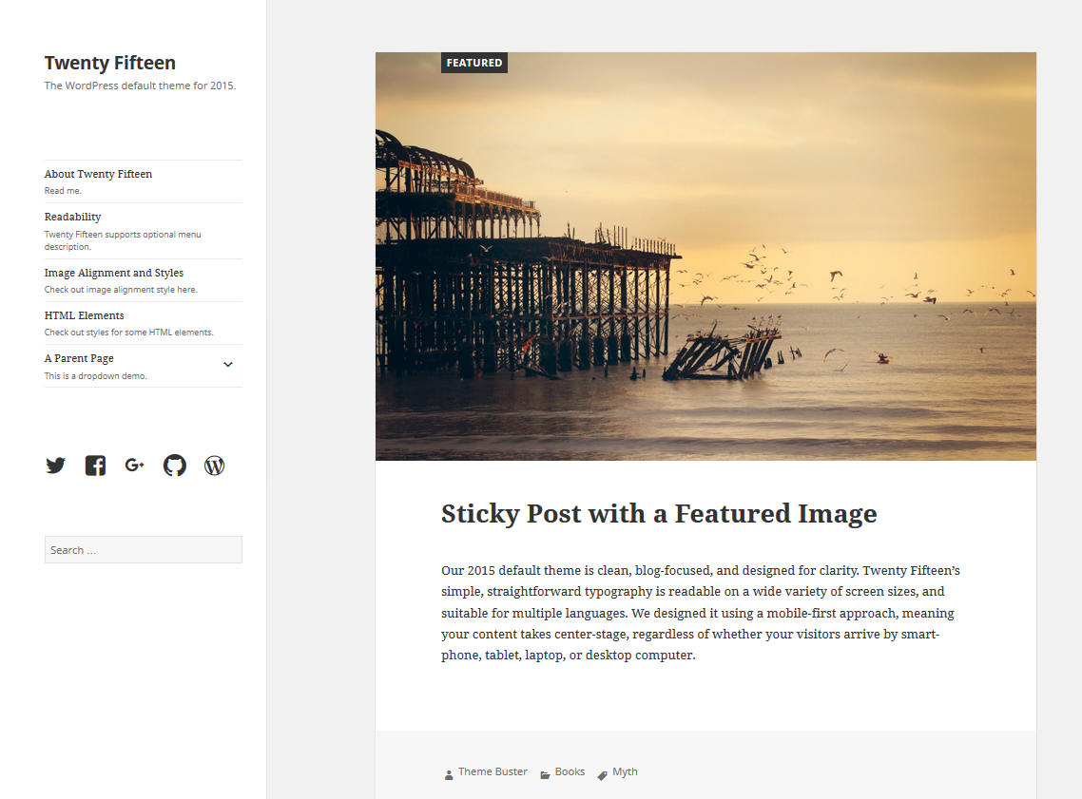
https://wordpress.com/theme/twentyfifteen/frankwaters.wordpress.com

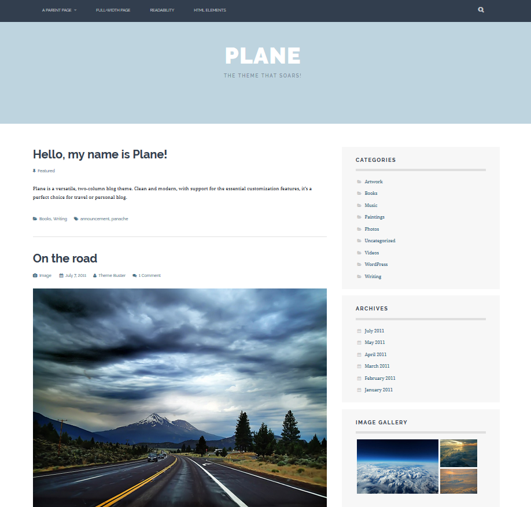

https://planedemo.wordpress.com/

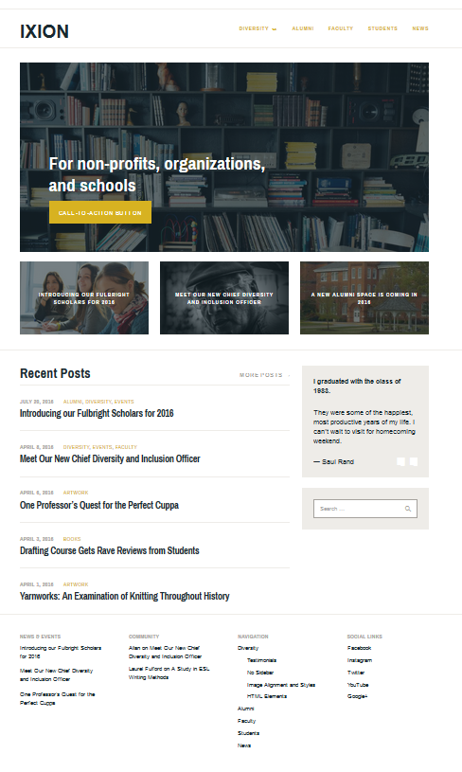
https://ixiondemo.wordpress.com/
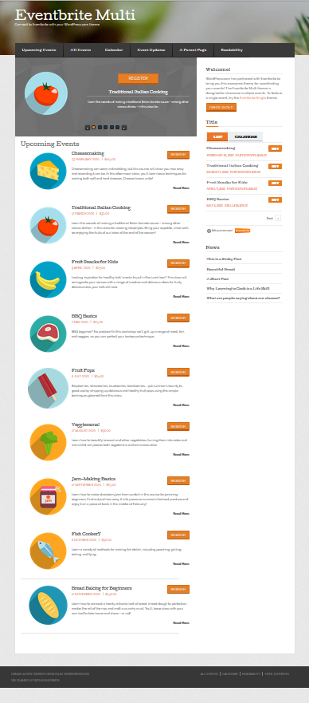
https://eventbritevenuedemo.wordpress.com

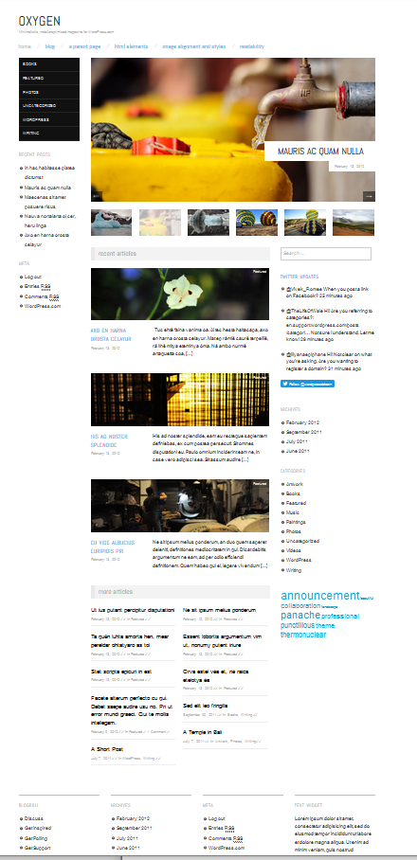
https://oxygendemo.wordpress.com/

